4th Conference on Nuclear Analytical Techniques (NAT2020) Jointed with 6th Symposium on Radiation in Medicine, Space, and Power (RMSP-VI)
November 12-13, 2020
Yuseong Hotel, Oncheon-ro 9, Yuseong-gu, Daejeon, Republic of Korea
http://radiationconference.org

Select Papers for Publications at JRNC / NET / JRPR

Dear NAT2020 & RMSP –VI Participants,
Thank you very much for your presence offline / online at NAT2020 & RMSP-VI is an honor and hopefully your suggestions / comments were helped a lot to presenters and participants. We are planning to bring out special issues in three different journals. The scopes of three journals are different. We request you please go through the journals scope and suitability of your work before submission of your manuscript to specified journal. Please feel free to contact me (nat2020conference@gamil.com) if you need any further information or to identify the suitable journal of your manuscript among three remoted journals.
JRNC: https://www.springer.com/journal/10967/aims-and-scope
NET:https://www.elsevier.com/journals/nuclear-engineering-and-technology/1738-5733/guide-for-authors
JRPR: http://jrpr.org/about/index.php
Each manuscript must be electronically submitted by the corresponding author using the Editorial Management system in the specified journal webpage.
Here I gave an example for manuscript submission to JRNC. Please carefully follow the instructions given below.
- Open JRNC EM system for online submission: http://www.editorialmanager.com/jrnc/
- If you are a user already, log in as “Author”. If you are not yet a user, please register first, then log in as an “Author”.
- Click on “Submit New Manuscript”.
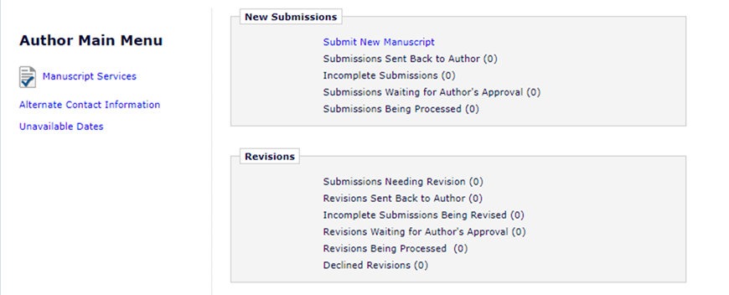
- From the drop down menu, select article type “S.I. : 4th Conference on Nuclear Analytical Techniques (NAT2020).
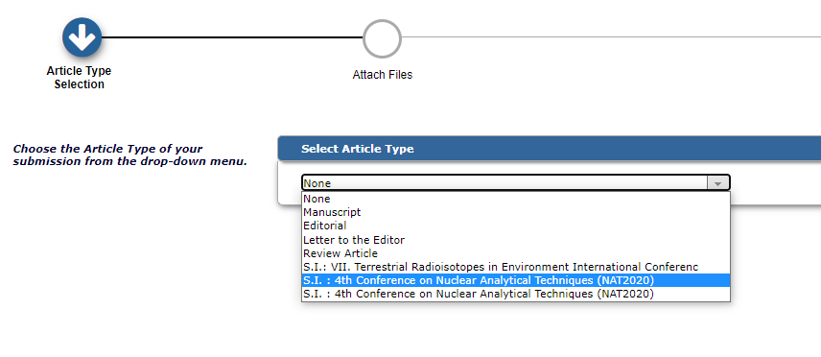
- Follow the instructions until you reach the page “Comments”. Insert your NAT2020 conference abstract number: xxx. Later you can insert any other comment if any.
- 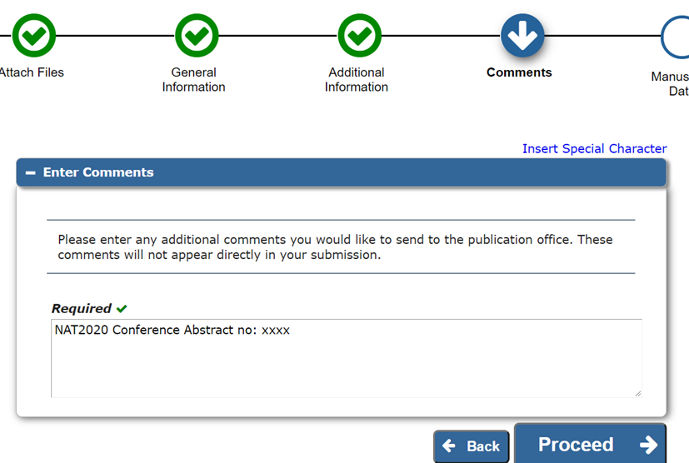
- Attach your manuscript in prepared using Microsoft Word software in doc or docx format. Do not upload in Pdf format!
Submission of manuscripts in LaTeX is also possible. For the moment, we cannot offer you template, please follow the instructions.
- Your manuscript should be prepared based on our manuscript template file. The template file in doc version could be downloaded from the JRNC home page:
https://www.springer.com/journal/10967/updates/17488614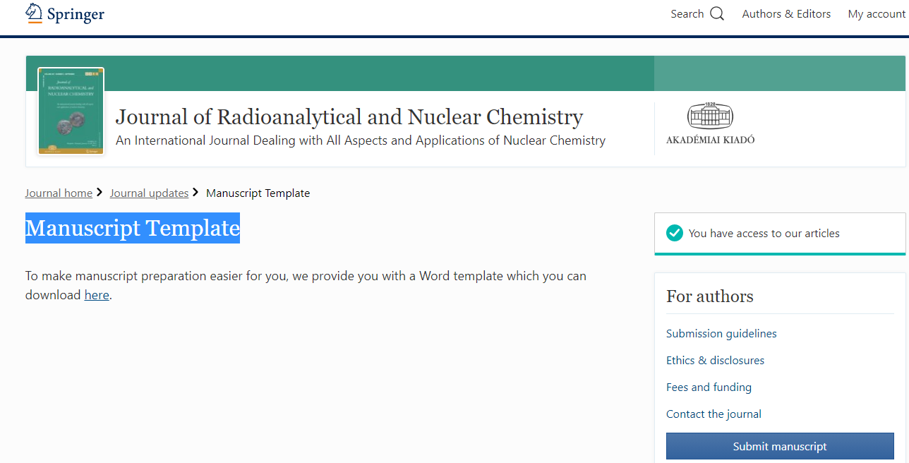
- Immediately after successful submission you will get an automated e-mail with “JRNC - Submission Confirmation” on the Subject line.
- Please consider the following points to avoid the auto-rejected
- Please use journal manuscript template
- The manuscripts should be uploaded in doc/docx and not in pdf version! Submission of manuscripts in LaTeX is also possible.
- Some abstracts are too long (maximum 50-100 words). Introductory remarks should be avoided!
- Tables should be submitted in editable format (doc/docx) and NOT as figures!
- Some figures are not good enough to reproduce. Figures should be submitted in tiff/jpeg format with 300 dpi resolution (min. 1200x1200 pixels).
- References should be well formatted. See our template!
.
Please do not hesitate to contact Tibor G. Kocsor (Tibor.Kocsor@akademiai.hu) if you face any problem in uploading your manuscript.
Please note that all manuscripts will be properly peer-reviewed while the final acceptance of the manuscript will be sent by editor-in-chief of journal.
Secretary, NAT2020 and RMSP-VI
KAERI, Daejeon, Korea
Email: nat2020conference@gmail.com

